**4G PERSONAL GPS TRACKER**

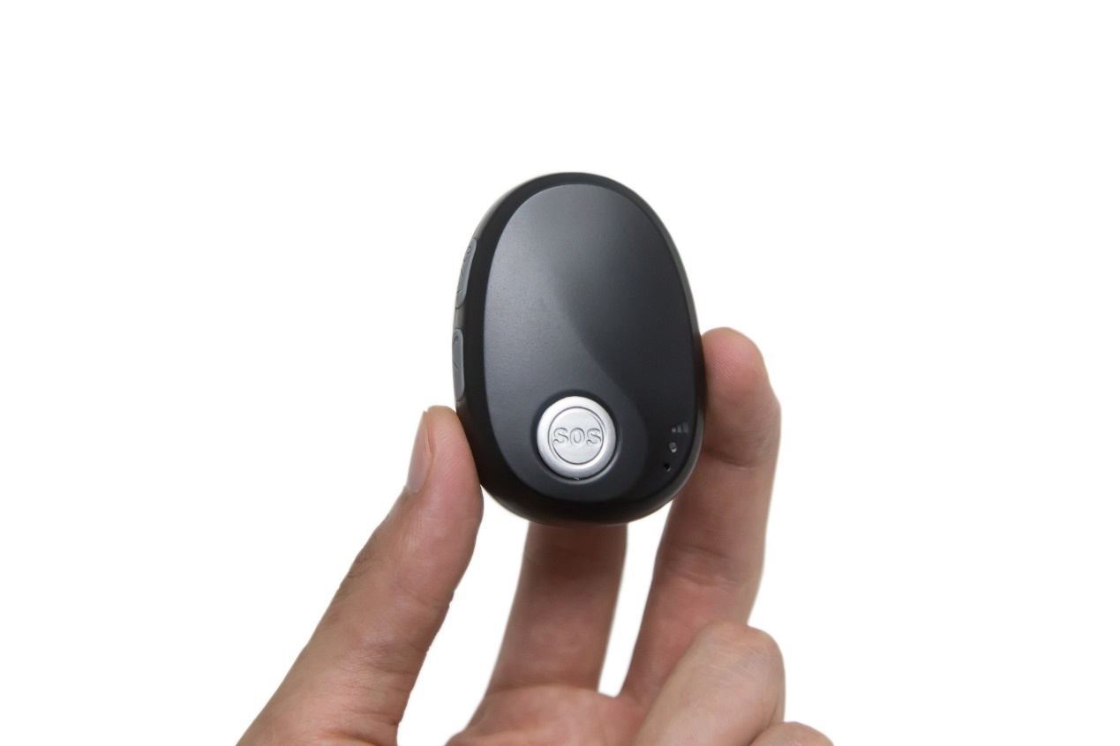

Foxi Q

**Content**

1. Product Overview 6

2. Product Main Functions 6

3. Product Appearance 7

4. Specification 8

5. Battery Working Time 9

6. LED Light 9

7. Insert the SIM Card 10

8. Charging 10

9. Tracking by phone 11

9.1 Setting SOS Number – B11 11

9.2 Setting SMS Message Time Zone – B14 11

9.3 Tracking by Calling 12

9.4 Tracking by SMS Command - C01 12

9.5 SMS Reply Content Example 13

10. Configuring in PC 13

11. Platform Tracking 14

12. Fall Down Detection 15

13. Loud Speaker 15

14. Power Saving 15

14.1 Normal Power Saving 15

14.2 Deep Sleep Mode Power Saving 16

# 1. Product Overview

FoxiQ is a latest generation 4G+2G LTE personal GPS tracker designed for the elderly, kids, employees, lone workers, pets, animals, and valuable asset tracking. It keeps a good balance between size and battery working life, the working time is up to 6.5 days at every 10 minutes tracking time interval. FoxiQ has passed IP67 waterproof standard, which is suitable for outdoor activities. With built-in microphone and speaker, FoxiQ supports two-way communication between the user and the preset SOS phone guardian. Powered by the built-in 3-axis motion sensor and excellent firmware algorithm, the FoxiQ device is able to detect the fall down event accurately.

# 2. Product Main Functions

* Real Time Tracking
* Mobile Phone Tracking
* Tracking by time interval
* Heartbeat interval
* Tracking by LBS
* Tracking by WiFi option
* Bluetooth
* Two-way calling
* Voice monitoring
* IP67 Waterproof
* SOS Alarm
* No movement alarm
* Fall down alarm
* Tilt alarm
* Internal battery low alarm
* 4 MB Flash Memory
* Long battery working time
* Smart power saving modes
* OTA

# 3. Product Appearance

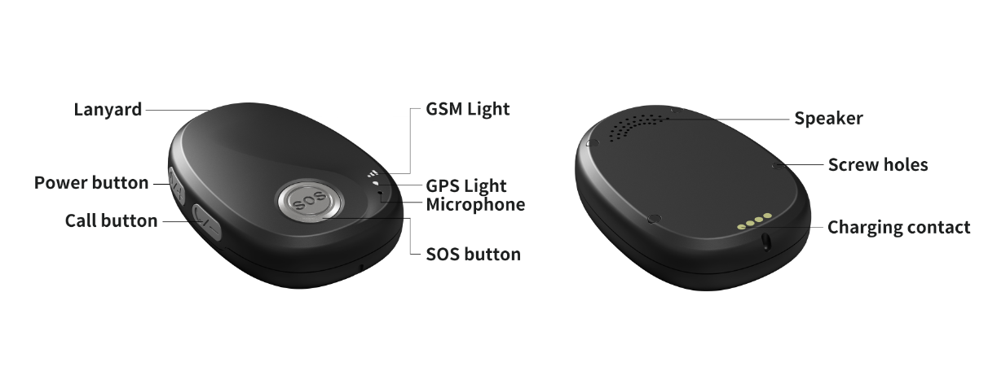

**Button Description**

|  |  |
| --- | --- |
| **SOS Button** | |
| Press SOS button for 2 seconds and feel the motor vibration | SOS alarm triggered |
| Short press SOS button | Hang up calling |
| Short press SOS button | Cancel fall down alarm |
| **Power Button** | |
| Press power button for 2 seconds | Power on or power off |
| Press (Power button + Call button) for 2 seconds | Enable Bluetooth |
| **Call Button** | |
| Short Press Call button to pick up call | Pick up incoming two-way call |
| Press Call button for 2 seconds to call | Call favorite contact number |
| Short Press Call button during calling conversation to adjust voice volume | Short press switch volume modes between default volume and the self-defined volume |

**Standard Packing Box**

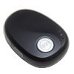 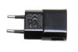 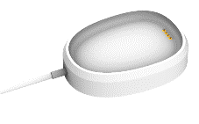

Main Unit Charger Charging cradle

**Optional Accessories**

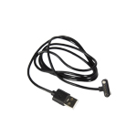 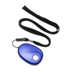 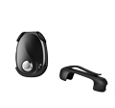 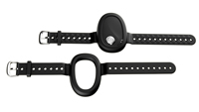 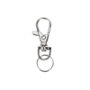

Data cable Lanyard Belt Clip Wristband Key ring

# 4. Specification

|  |  |  |
| --- | --- | --- |
| **Item** | **Specification** | |
| Dimension | 65*46*17mm | |
| Weight | 48g | |
| GSM Module | Quectel EG915U, Cat 1 type | |
| GPS Chipset | ZKW AT6558R | |
| Charging Voltage | DC 5V/1A | |
| Internal Battery | 1000mAh/3.7V Lithium-ion battery | |
| Full charging time | <2 hours 10 minutes | |
| Power Consumption | Average 2.4mA standby current | |
| Working hours | Refer to chapter 5 for details. 5 minutes time interval working for 4 days 20 hours | |
| Microphone | Built-in microphone | |
| Speaker | Built-in speaker | |
| Operating Temperature | -20℃~70℃ | |
| Humidity | 5%~95% | |
| Waterproof | IP67 (Testing condition: Immersed in 20cm depth water for 30 minutes) | |
| LED Light | 2 LED lights indicate GPS/GSM/Power status | |
| Button/Switch | 1 SOS button, 1 power button, 1 call button | |
| Flash Memory | 4MB (Buffer storage: GPRS 8000 units, SMS 400 units) | |
| Motion Sensor | 3-axis motion sensor (Fall down/Movement detection) | |
| Vibration motor | Built-in, vibration reminder incoming call/button press | |
| WiFi | 2.4 GHz 802.11b (Rx) | |
| Bluetooth | BlueTooth Low Energy (BLE4.2 BR/EDR) | |
| Frequency Band | **EU version:** for Asia, Europe, Middle East, Africa, Australia countries | **2G** GSM: B2/B3/B5/B8 |
| **4G** FDD-LTE: B1/B3//B5/B7/B8/B20/B28 |
| **LA version:** for Latin America countries | **2G** GSM: B2/B3/B5/B8 |
| **4G** FDD-LTE: B2/B3/B4/B5/B7/B8/B28/B66 |
| USA and Canada | **Don’t support** |
| GPS Sensitivity | -167dBm | |
| GPS Start Speed | Cold start 30s, hot start 1s | |
| Position Accuracy | 2.5m | |
| Charging Cradle | Available, standard packing accessory | |
| Charging Port | 1 magnetic contact port for Configuring/Upgrading/Debugging | |

# 5. Battery Working Time

FoxiQ has a built-in 1000mAh rechargeable lithium-ion battery. Longer battery working time is one of our core design goals from the beginning. After hard efforts on the firmware and hardware development, now we can achieve below excellent results:

|  |  |
| --- | --- |
| **Testing conditions (GPS signal available, WiFi turn off, B71 is 0)** | **Working time** |
| 30 seconds time interval | 18 hours |
| 60 seconds time interval | 36 hours (1 day 12 hours) |
| 300 seconds (5 minutes) time interval | 116 hours (4 days 20 hours) |
| 600 seconds (10 minutes) time interval | 157 hours (6 days 13 hours) |
| 3600 seconds (1 hour) time interval | 212 hours (8 days 20 hours) |
| 86400 seconds (24 hours) time interval | 243 hours (10 days 3 hours) |
| Standby (Time interval is 0) | 249 hours (10 days 9 hours) |

# 6. LED Light

|  |  |
| --- | --- |
| **GPS Light (Green)** | |
| Flash 0.1s on and 3s off | GPS valid |
| Flash 2s on and 2s off | Searching GPS signal |
| **GSM Light (Orange)** | |
| Flash 0.1s on and 3s off | GRPS connected |
| Flash 2s on and 2s off | GSM searching |
| flash every 0.1s | Initial, device start or No SIM card insert |
| **Battery status (Both GPS and GSM lights flash synchronously)** | |
| Both flash 3s on and 3s off | In sleep mode |
| Both off | Power off |
| Both flash every 0.1s | Low battery |
| Both solid on | On charging |
| Both flash 0.1s on and 3s off | Battery recharging full |

# 7. Insert the SIM Card

* The SIM card type is **Nano SIM card**
* Ensure the SIM card has GPRS data plan
* Ensure the PIN code has been closed.
* Power off device before Insert SIM card

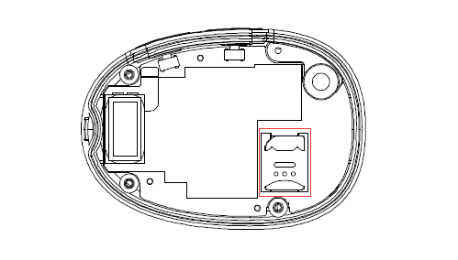

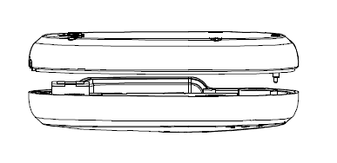

Screw out the back case then you will find the SIM card slot, insert the Nano SIM card correctly.

# 8. Charging

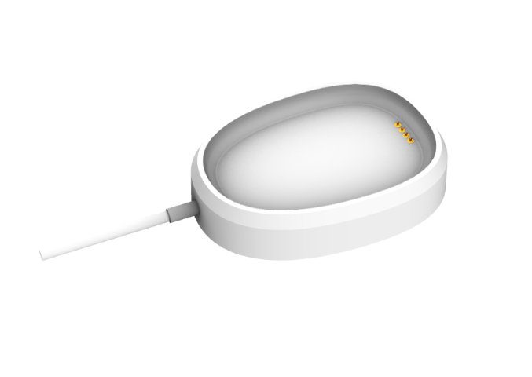

Charging by charging cradle.

The original charger is DC5V/1A

**Full charging time: <2 hours 10 minutes**

The GSM and GPS lights flash **synchronously** to indicate battery status, details are below

|  |  |
| --- | --- |
| Both flash 3s on and 3s off | In sleep mode |
| Both off | Power off |
| Both flash every 0.1s | Low battery |
| Both solid on | On charging |
| Both flash 0.1s on and 3s off | Battery recharging full |

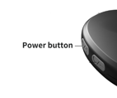

**Turn on device**

Press power button for 2 seconds to turn on/turn off device

# 9. Fall Down Detection

“Fall down” is a state that a person who falls down freely.

Powered by the FoxiQ model built-in 3-axis motion sensor and our excellent algorithm in firmware, The FoxiQ device can detect the fall down event with higher accuracy, and reduce the false alerts to minimum.

# 10. Loud Speaker

Some users are elders, the loud speaker can help them hear more clearly. Besides the default fixed volume mode, we provide option to allow the user to set up the self-defined volume by adjusting the microphone and speaker sensitivities.